PROJECT 2:

Deploying a web server in Windows instanceTask

1:Create a windows instance using AMI :Ubuntu Server 18.04 LTS (HVM)Task

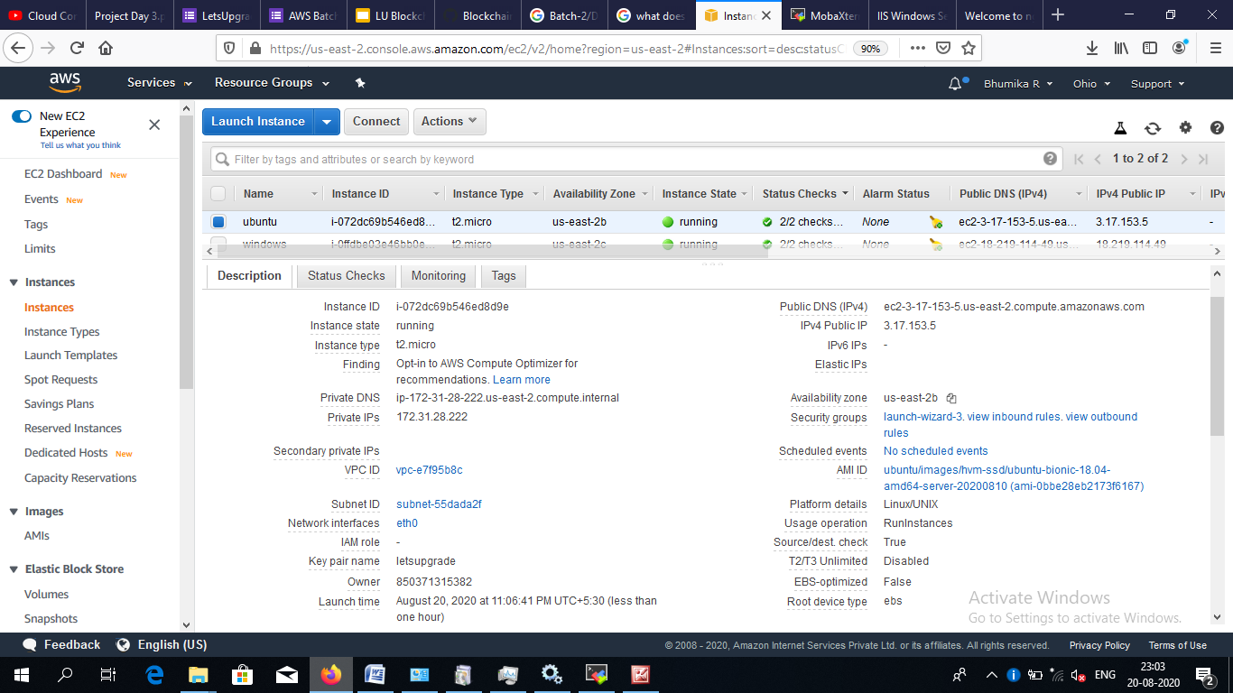

2:Download and install MobaXterm Portable Edition

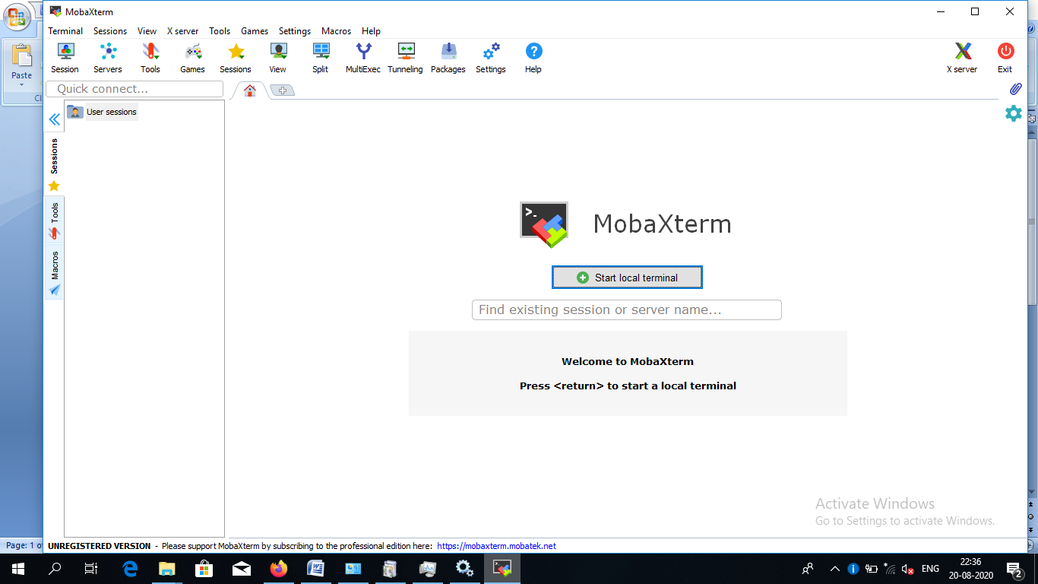

Task 2:Launch the Ubuntu instance using SSHNote:Username is ubuntu

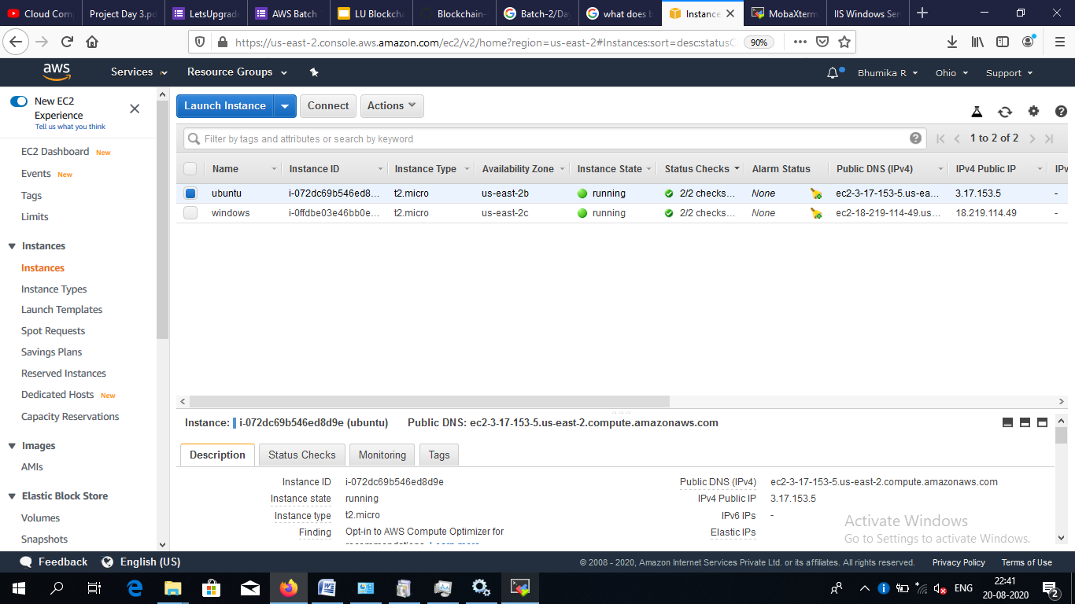

Task 3:Install ngnix web server using bashNote:Simply copy the command below and paste in the bash to install the ngnix web server.

sudo apt-get -y update

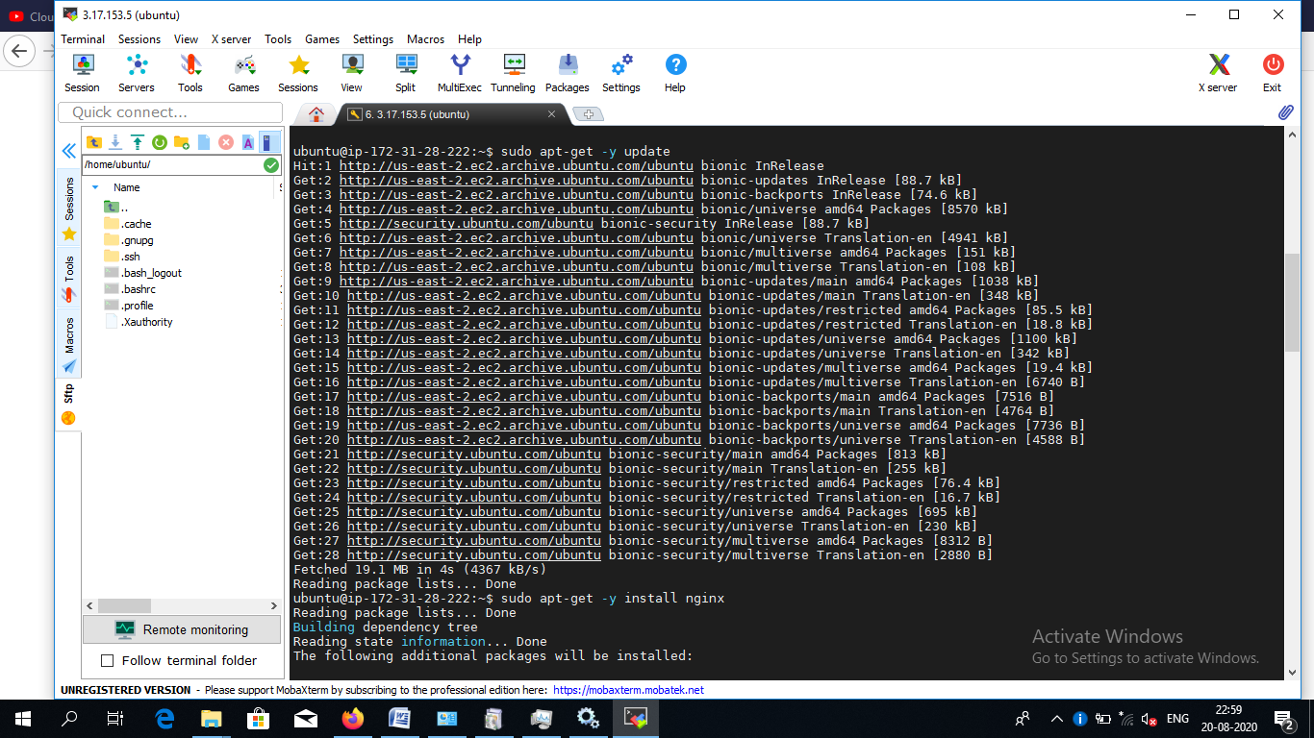

sudo apt-get -y install nginx

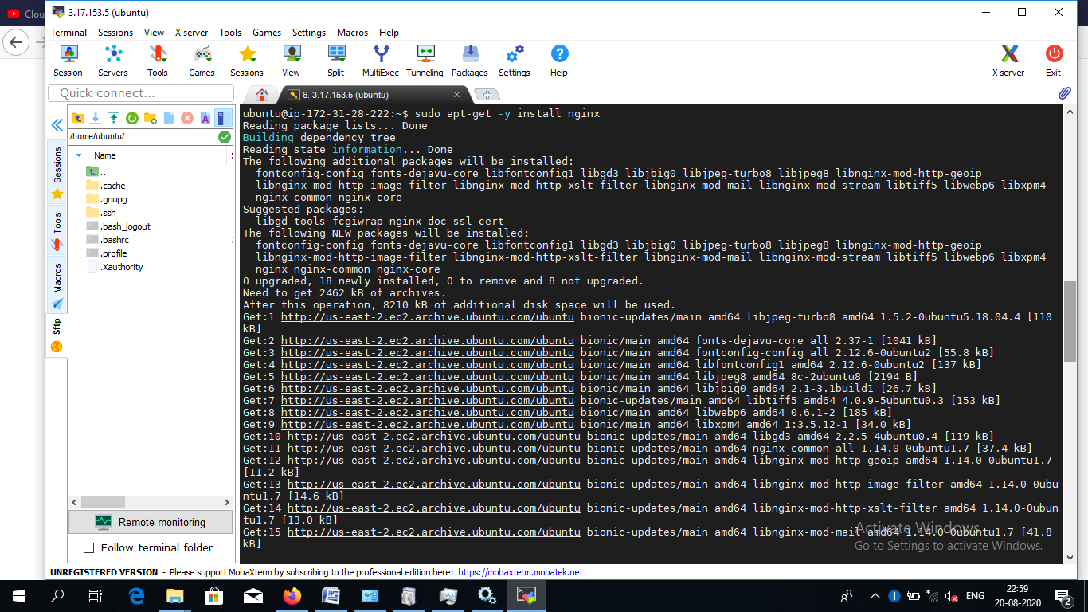

Task 4:Verify successful installation of ngnixNote

You should be able to see the Welcome to ngnix Web page when you paste the public IP into the browser

